**Provide Header, Dedication, Acknowledgement, Content, Table, etc.**

**ABSTRACT**

It is a familiar fact that pure substances tend to exist in one of three distinct states: solid, liquid, and gas. Take water, for example, as ice is heated at atmospheric pressure, it suddenly melts into liquid at a specific temperature of 320 F.As the liquid continues to be heated, it eventually reaches a temperature of 1000 C at which it spontaneously vaporizes into a gas. These transitions are discontinuous i.e they occur at specific state conditions of particular combinations of temperature and pressure. At exactly those conditions, the system can exist in more than one form such that two (or more) phases are in equilibrium with each other.

A Phase is homogeneous region of matter in which there is no spatial variation in average density, energy, composition, or other macroscopic properties. Phases can also be distinct in their molecular structure. For example, water has multiple ice phases that differ in their crystallographic structure. A phase can be considered a distinct “system” with boundaries that are interfaces with container walls or other phases.

The major objective of this project is to maximize the recovery of heavy components of the intermediate group in crude oil, to save the heavy group components in liquid product and to separate the Light Group (C1 and C2) from oil with the application of phase equilibrium calculation method

**TABLE OF CONTENT**

* 1. Introduction
  2. Scope of study
  3. Limitation of study
  4. Objectives of study
  5. Significance of study
  6. Project Methodology
  7. Organization of project

**CHAPTER ONE**

* 1. **INTRODUCTION**

It is a familiar fact that pure substances tend to exist in one of three distinct states: solid, liquid, and gas. Take water, for example, as ice is heated at atmospheric pressure, it suddenly melts into liquid at a specific temperature of 320 F.As the liquid continues to be heated, it eventually reaches a temperature of 1000 C at which it spontaneously vaporizes into a gas. These transitions are discontinuous i.e they occur at specific state conditions of particular combinations of temperature and pressure. At exactly those conditions, the system can exist in more than one form such that two (or more) phases are in equilibrium with each other.

A Phase is homogeneous region of matter in which there is no spatial variation in average density, energy, composition, or other macroscopic properties. Phases can also be distinct in their molecular structure. For example, water has multiple ice phases that differ in their crystallographic structure. A phase can be considered a distinct “system” with boundaries that are interfaces with container walls or other phases.

The processing of natural gas invariably involves the thermodynamic manipulation of its volume, temperature and pressure conditions to “force” the gas mixture into two phases liquid and gas which get separated in order to produce merchantable hydrocarbons gas mixture containing mostly methane.It also involves the removal of contaminants.The response of the natural gas upon subjection to temperature-pressure condition and the quantities of the phases(liquid & gas) produced, all depend on the phase behaviour of the natural gas.

The phase behaviour can then be defined as the changes in phase exhibited by the natural gas when subjected to different temperature-pressure conditions. During production, the hydrocarbon molecules undergo various phase- and property-altering intermediate stages which are crucial in designing and operating the processes efficiently and optimally.

Vapor–liquid equilibrium is a condition in which a liquid and its vapor (gas phase) are in equilibrium with each other, a condition or state where the rate of evaporation (liquid changing to vapor) equals the rate of condensation (vapor changing to liquid) on a molecular level such that there is no net (overall) vapor–liquid interconversion. A substance at vapor–liquid equilibrium is generally referred to as a saturated fluid. For a pure chemical substance, this implies that it is at its boiling point.The notion of "saturated fluid" includes saturated liquid (about to vaporize), saturated liquid–vapor mixture, and saturated vapor (about to condense).

Although theoretically equilibrium is never reached, equilibrium is practically reached in a relatively closed location if a liquid and its vapor are allowed to stand in contact with each other with no interference or only gradual interference from the outside. However, this does not apply to cases of intensive heat exchange or rapid pressure change.

**GAS AND LIQUID IN EQUILIBRIUM**

A phase diagram is a Temperature-Pressure Diagram Illustrating Various Conditions (T-P) Under Which Different Phases of a System (Substance) Exist. Diagram that indicates whether substance exists as Solid, Liquid or Vapour at any Given Temperature and Pressure. A Pictorial Representation of the Conditions of Temperature and Pressure for Each Phase of a Pure Substance.

The Phase Diagram Also Describes the Temperatures and Pressure Where the Phases Are in Equilibrium.

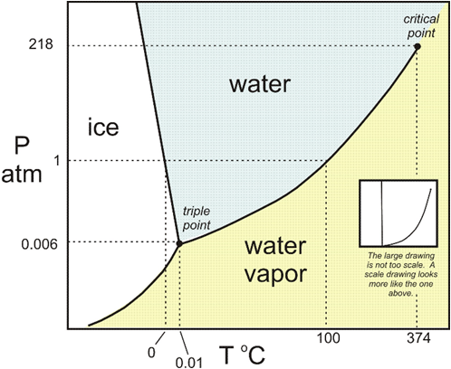

**Figure 1.1: Pure Substance (water) Phase Diagram**

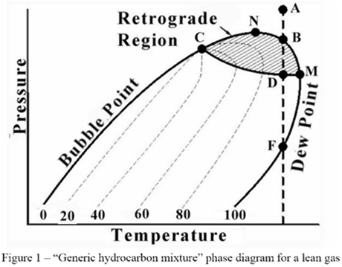

**Figure 1.2: Multi-components Phase Diagram**

**PHASES IN EQUILIBRIUM**

1. Region Between Bubble Point and Dew Point Lines
2. Region Where Gas and Liquid Phases in Equilibrium
3. Quantities and Compositions of Phases are Different for each Set of Pressure and Temperature

**Features of System in Equilibrium**

* 1. System is at Rest
  2. No Changes Taking Place
  3. Inter-Molecular Forces of Repulsion and Attraction are Equal
  4. Exists Without Change in:
     1. Pressure
     2. Temperature
     3. Molecular Attraction
     4. Molecular Repulsion

**Equilibrium Calculation**

* 1. Calculations Used to Determine Quantities and Components of Gas and Liquid of Mixture in Equilibrium
  2. Uses of Equilibrium Calculation
     1. Prediction of Behaviour and Composition of Reservoir Fluid
     2. Determination of Optimum Conditions for Processing Reservoir Fluid
  3. Equilibrium Calculation Methods
     1. Bubble Point Method
     2. Dew Point Method
     3. Within Equilibrium Region Method
  4. **SCOPE OF STUDY**

The scope of this project covers the **design, development and application of a new software (give it name of your choice) to carry out** separator equilibrium calculations to determine composition of reservoir fluid and to determine the optimum condition for the processing of the reservoir fluid at the separator for maximum liquid recovery from the hydrocarbon system.

* 1. **LIMITATIONS OF STUDY**

This study is limited to the application of thermodynamic equilibrium to reservoir fluid in order to predict the behavior and composition of the fluid at the separator.

* 1. **OBJECTIVES OF STUDY**

The aim and objectives of this project are;

1. To design a New Software(XYZ) to handle phase equilibrium calculations
2. Apply XYZ to separate the Light Group (C1 and C2) from oil.
3. Apply XYZ to maximize the recovery of heavy components of the intermediate group in crude oil.
   1. **SIGNIFICANCE OF STUDY**

The significance of study is to develop software that can be used to handle phase equilibrium calculations in order to determine hydrocarbon fluid composition at the separator, stock tank Gas-Liquid equilibrium, stock tank liquid density, Gas-Oil ratio, and reservoir liquid density and Formation volume factor for a given reservoir fluid composition.

* 1. **ORGANIZATION OF PROJECT**

The study is divided into five chapters. The outline and organization of this project are as follows:

1. Chapter one presents an overview of the research study, the goals and objectives are presented.
2. Chapter two presents a literature review. This part will include the concepts of phase equilibrium, and its limitations.
3. Chapter three is methodology.
4. Chapter four presents the result of the methodology of the research as illustrated in chapter three.
5. Chapter five is conclusions and recommendations.

**CHAPTER TWO**

**2.1 LITERATURE REVIEW**

The understanding of the behaviour of any hydrocarbon system stems from the behaviour of the individual molecules making up that system. On the other hand, the behaviour of the hydrocarbon system to be studied will be as a result of the responses or behaviour put forth by the system on application of and/or due to changes in Temperature and Pressure. In consideration of the above, we shall start with the investigation of the behaviour of the hydrocarbon molecule.

Three basic factors that are very crucial to the behaviour of molecules are:

1. **Temperature of the System**:

This is the reflection of the kinetic energy of the molecules in the system. It is simply a physical measure of the kinetic energy of the molecules of the material. If heat is added to a system, the kinetic energy is increased and this results in increase in molecular motion which results in tendency for the molecules to move apart. The temperature is increased in the process.

1. **Pressure of the System:**

This is the reflection of the number of the molecules present in the system per given space frame and their motion. It is in effect the number of times these molecules strike the walls of the container of the system. This is more explicit in a gas system. As the molecules are forced closer and together, the pressure increases.

Δ p = p i , x − p f , x = p i , x − ( − p i , x ) = 2 p i , x = 2 m v x , {\displaystyle \Delta p=p_{i,x}-p_{f,x}=p_{i,x}-(-p_{i,x})=2p_{i,x}=2mv_{x},} 

Where *p* is the momentum, *i* and *f* indicate initial and final momentum , *x* indicates that only the *x* direction is being considered, and *v* is the speed of the particle .

1. **Molecular Attraction and Repulsion of the Molecules within the System.**

Straight away, it is clear that while pressure and molecular attraction will be pushing the molecules together, temperature and molecular repulsion will be pulling them apart. These two situations are responsible for the state of system. When these two forces are in equilibrium, the material or system is at rest and no changes whatsoever is taking place. However, when the system is NOT at rest, such as when liquid is at its freezing point, liquid is at its boiling point, or gas is at its due point, these two forces are unbalance and the system is undergoing changes. This change continues until the forces are balanced and the system comes to rest. When the molecules of a system are far apart, such as in gas, the attractive force between the molecules is high, pulling them together. This attraction force continues until the distance between the molecules is so short that the molecules electronic fields will overlap. Any further decrease after this will result in repulsive force between the molecules and this repulsive force will increase, as the molecules are forced further together.

Consequently, in liquids, there exists a repulsive force between the molecules. This repulsive force is responsible for the resistance put up by the liquid when subjected to compressive forces.

**2.2 PHASE, PHASE BEHAVIOUR AND PHASE DIAGRAM OF HYDROCARBON SYSTEM**

**PHASE**

Phase is defined as any homogenous and physically distinct part of a system, which is quite separated from other parts of the system by definite bounding surfaces. Example is the three phases of water; Ice (solid), water (liquid) and water vapour (gaseous). Note that vapour and gas are the same and the two terms will be used here likewise. Water is therefore a three-phase system.

However, depending on the temperature and pressure, solids can take on different crystalline forms which are regarded as different phases. Petroleum fluids however are not overly involved with crystalline forms.

The appropriate way to study the behaviour of hydrocarbon system is through the investigation of the phase behaviour of the systems.

**PHASE BEHAVIOUR OF HYDROCARBON SYSTEM**

Phase behaviour refers to the conditions of pressure and temperature under which different phases exist. In this study, three major variables will be considered namely; pressure, temperature and volume. When pressure and temperature are imposed, the resulting phase is then determined by the volume or density.

Generally, a hydrocarbon system is made up of different substances or components, but in order to understand their behaviour, it is necessary first, to have an understanding of the behaviour of a pure substance.

### PHASE DIAGRAM FOR PURE SUBSTANCE

The phase diagram is a pressure-temperature diagram which illustrates the various conditions under which the different phases of a substance may exist.

Fig. 2-1 is a typical example of a phase diagram showing pressure plotted against temperature. It is made up of two curves, BTC and TA meeting at point T. These two lines separate the states of the substance into three main phases.

### The Vapour-Pressure Line

This is line TC which is the dividing line between the region where the substance is a liquid and the region where it is a vapour or gas. The pressure-temperature points which lie above this line are in the liquid state, while such points which lie below the line are in the vapour or gaseous state. The conditions under which liquid and gas co-exist are indicated by points exactly on the pressure-vapour line. For any particular temperature, these points are also the bubble point pressure (for the liquid) and the dew point pressure (for the gas).

**Phase Transition**

The term phase transition is most commonly used to describe transitions between solid, liquid and gaseous states of matter, and, in rare cases, plasma. A phase of a thermodynamic system and the states of matter has uniform physical properties. During a phase transition of a given medium certain properties of the medium change, often discontinuously, as a result of the change of some external condition, such as temperature, pressure, or others. For example, a liquid may become gas upon heating to the boiling point, resulting in an abrupt change in volume. The measurement of the external conditions at which the transformation occurs is termed the phase transition. Phase transitions are common in nature and used today in many technologies

1. **Bubble Point**

This is the point at which the first bubble of gas will form out of the liquid as a result of pressure

Drop or temperature increase.

As pressure is dropped from point 1 (Figure 2.2) in the liquid phase isothermally, the molecules are pulled from one another, the intermolecular distance gets longer and their kinetic energy increases. At a point on the vapour pressure line, a gas bubble will form and comes out.

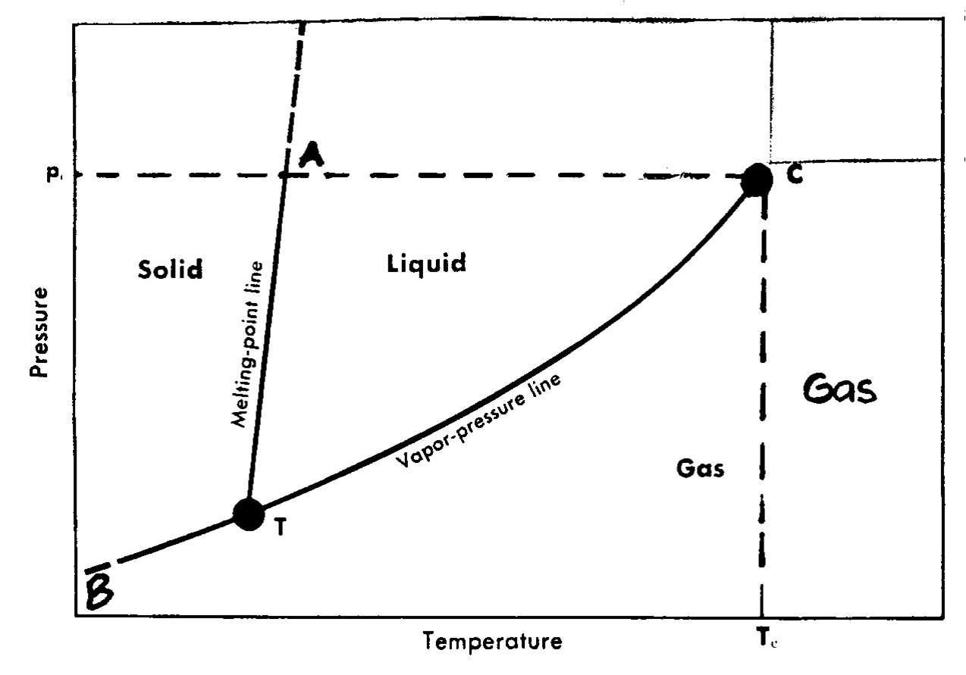

**Fig 2.1 Pure substance phase diagram**

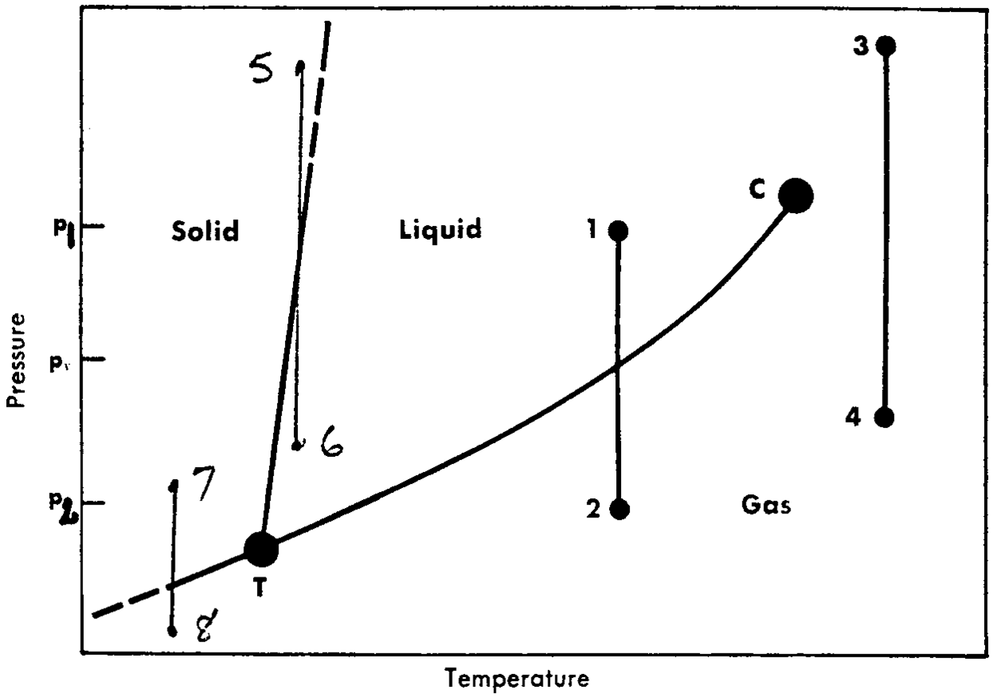

**Fig 2.2: Pure Substance Phase Diagram Indicating Isothermal Expansion**

1. **Dew Point**

Conversely, looking at it from the gas phase, starting from pressure at point 2 which is totally gas, as the pressure increases at constant temperature, the molecules are compressed, loosing the intermolecular distance and kinetic energy. At the vapour pressure line, a drop of liquid (vapour) will form. This is the dew point. For a pure substance, the gas dew point and the liquid bubble point are the same. The above described trend with constant temperature for bubble/dew points, melting/crystallisation points and sublimation points as in Fig 2.2, also applies when pressure is held constant and temperature is increased or decreased. Fig 2.3 uses a mercury and pure substance liquid filled cylinder cell to illustrate this relationship in the liquid/vapour section of the phase diagram. Temperature is increased by addition of heat, while the pressure is held constant by the removal of mercury from the cell. At condition A which corresponds to point 1 in Fig 2.4, the cell is full of liquid (liquid state). With subsequent application of heat, gas forms out of the liquid and co-exists with liquid at constant pressure until all the liquid has evaporated and the cell is full of only gas at condition D in Fig 2.3 (The dew point). Subsequent heat application results in expansion of gas. Fig 2.4 is a phase diagram depicting these conditions.

A cautionary note must be addressed here. Vapour drop actually forms from a saturated gaseous state of any substance as a result of reduction in kinetic energy and inter-molecular space due to pressure increase or/and temperature decrease. On the other hand, with the opposites of the above measures, liquid molecules will gain enough energy to vaporise to vapour in the gaseous phase. This is commonly referred to as gas (vapour) bubbling out of the liquid. So, although there is a marked difference between a gas bubble and a vapour drop, these two terms, vapour and gas, will be used interchangeably in this project.

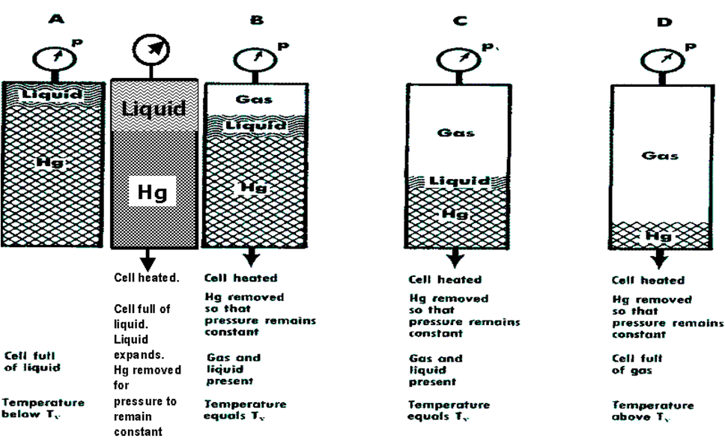

**Fig 2.3 Vaporization of pure substance at constant pressure**

**The Melting Pont Line**

This is line TA which divides the solid and liquid phases. The points along this line indicate all pressure-temperature conditions for the co-existence of liquid and solid phase of the substance. Line 5-6 shows that as pressure drops at constant temperature, the same phenomenon of decrease in molecular attraction attended with increase in kinetic energy occurs until a point on the melting point line is reached and a drop of liquid begins to form.

Conversely, if pressure is progressively increased in the liquid phase from point 6, on getting to the melting point line, ice or solid will begin to form. This is also crystallisation point for a pure substance.

It should be noted however, that in the crystallisation section, there are many different types of melting point lines, depending on the substance. But petroleum substances have only one melting point line and as such, we will not bother with different crystallisation lines which give rise to different phases of crystals.

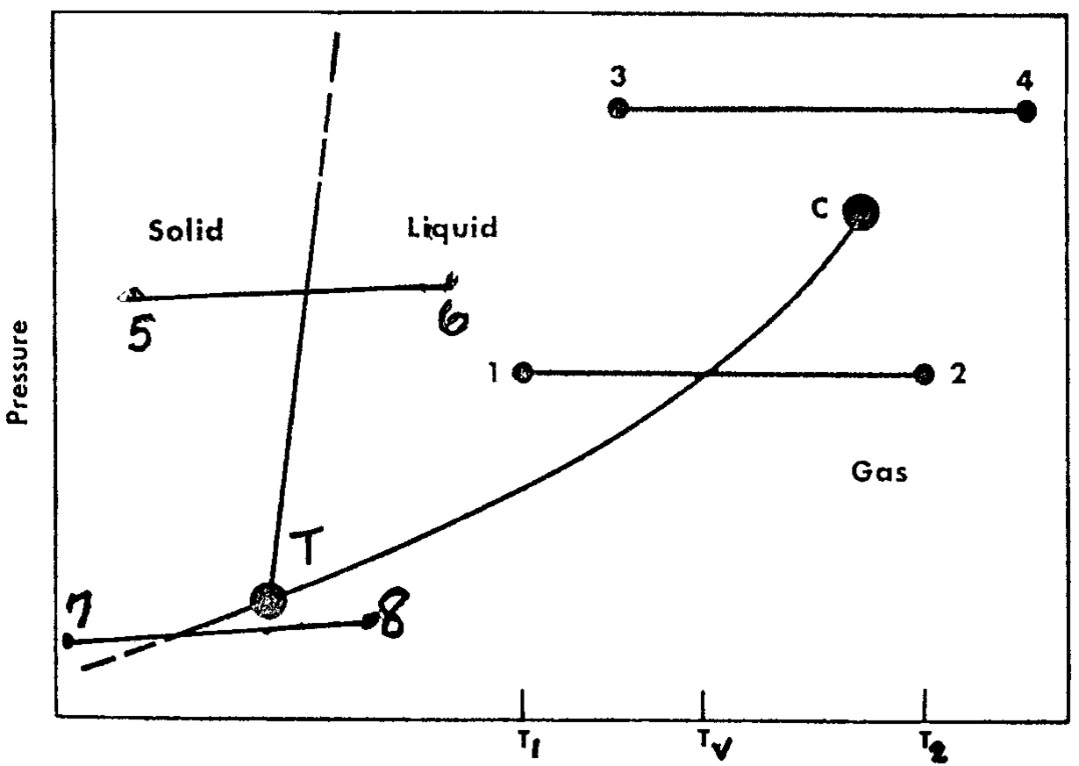

**Fig. 2.4 Pure Substance Phase Diagram Illustrating Isobaric Temperature Chang**

### 2.3 OIL-GAS SEPARATION and SAPARATION METHODS

The understanding of the underlying theory of oil and gas separation of the typical reservoir effluent of hydrocarbon mixtures require basic assumption of such effluent mixture being made up of three main groups of hydrocarbons:

1. The **Light Group** consisting of Methane (**CH4**) and Ethane (**C2H6**)
2. The **Intermediate Group** consisting of the Propane/Butane (**C3H8**/**C4H10**) group and Pentane/Hexane (**C5H12**/**C6H14**) group
3. The **Heavy Group** consisting of Sexan-Plus (**C7H16**+) which is the bulk of crude oil.

The main objectives of gas–oil separation process are to try to achieve the followings:

1. To separate the Light Group (C1 and C2 ) from oil

2. To maximize the recovery of heavy components of the intermediate group in crude oil

In the process to accomplish the above objectives, some hydrocarbons of the Intermediate group are invariably lost in the gas stream. In order to minimize this loss and maximize liquid recovery, two methods of separation which are mostly employed in the industry (Differential or enhanced separation and Flash or equilibrium separation) are compared below:

1. **Differential or Enhanced Separation Process**

In the differential separation, the light gases (light group) are gradually and almost completely separated from oil in a series of pressure stages, as the total pressure on the well-effluent mixture is being reduced at the separators. The Differential separation process is characterized by light gases being discretely separated out of the oil as soon as they are liberated on pressure reduction. It is thereforecharacterized by complete disengagement of the gas and oil whereby the light components do not come into contact with the heavier hydrocarbons; instead, they find their way out of the separator upon liberation.

**2. Flash Vaporisation or Equilibrium Separation**

When pressure confining a mixture in a container, is released or reduced, the mixture is allowed to undergo a partial vaporisation whereby some quantity of gas comes out of the mixture. This process is known as ***Flash Vaporisation.***

In the flash vaporization separation, the gases liberated from the oil remain in intimate contact with the oil and a thermodynamic equilibrium is established between the two phases and separation takes place at the equilibrium pressure.

Flash vaporisation occurs in separators and other surface equipment giving rise to gas and liquid in equilibrium. If it can be assumed that the product of flash vaporisation, the gas and liquid will remain together and in contact for sufficient period of time, to be able to attain equilibrium, then the equilibrium calculation equations for non-ideal mixture can be applied. The same method will then be used to calculate the composition and quantity of the gas and liquid from the flash vaporisation.

As will be seen later in the separation section of this study, the feed from the flow line is brought to equilibrium in the separator by the separator pressure and temperature. While the separator pressure is maintained or controlled by pressure-controlling devices, the temperature which depends on the feed and atmospheric temperatures and cooling due to vaporisation of part of the feed, is normally controlled by either heating or refrigeration where necessary.

**COMPARISON OF FLASH AND DIFFERENTIAL SEPARATION PROCESSES**

In differential separation, the liberation of heavy hydrocarbons (intermediate and heavy groups) into gaseous phase is maximum and oil-volume shrinkage experienced by crude oil in the storage tank is minimal. This is mostly as a result of the fact that separations of most of the light gases take place at the earlier high-pressure stages of separation. On this basis, the flash separation can be adjudged to be inferior to differential separation as the flash separation experiences greater losses of heavy hydrocarbons that are carried away with the light gases due to equilibrium conditions.

Oil and gas industry experience, nevertheless, indicates that commercial separation based on the differential concept is quite expensive and therefore considered not a practical approach because of the many stages required. This therefore rules out differential separation as a viable option. Flash separation process main scheme is to effect gas–oil separation using a small number of stages in the oil and gas industry. However, in terms of efficiency, it must be noted that a close approach to differential separation by flash separation can only be reached by using four to five flash separation stages. The table below show other parameters of comparison between the mechanisms of separation by the two methods.

|  |  |  |  |
| --- | --- | --- | --- |
| **No.** | **Parameter** | **Flash Separation** | **Differential Separation** |
| **1.** | Losses of hydrocarbon | High | Low |
| **2** | No. of stages | Few (2–4 stages) | Too many (can reach 100 stages) |
| **3** | Commercial application | Regularly Applied | Not Applied |
| **4** | Comparison Based on Number of Stages vis-à-vis Separation Efficiency | No. of flash stages of Flash Separation | Percent approach to Differential Separation |

**Table 2.1:** **Comparison of Flash and Differential Separation Processes**

**2.4 EQUILIBRIUM CALCULATIONS**

These are the calculations to determine the quantities and components of gas and liquid of a mixture in equilibrium.

### 1. Uses of Equilibrium calculations.

1. To predict the behaviour and composition of reservoir fluid.
2. To determine the optimum condition for the processing of the reservoir fluid at the separator.

### 2. Methods of Equilibrium Calculation

1. Bubble Point.
2. Dew point.
3. Within the equilibrium.

### 3. Ideal Solution

We will investigate the phase equilibrium of ideal solution as a stepping stone to real solutions investigation. The deviations of real solution will then be analysed to have a better understanding of real solution phase equilibria.

**a. Properties of Ideal solution**

1. Components of ideal solution have mutual solubility when mixed.
2. No chemical reaction takes place within the mixture.
3. Molecular diameters of the components are the same so that their mix is uniform.
4. Inter-molecular forces of attraction and repulsion are the same between like molecules as well as unlike molecules.
5. No heat is generated or taken
6. The volume of ideal solution is the sum of the volumes of the components

Generally, ideal solution does not exist. However, solution of gas mixtures and liquid mixtures of some of the same homologous series do approach ideal solution behaviour. This will definitely assist us in understanding the behaviour of real solutions.

**b. Compositions and Quantities of Gas and Liquid of an Ideal Solution in Equilibrium**

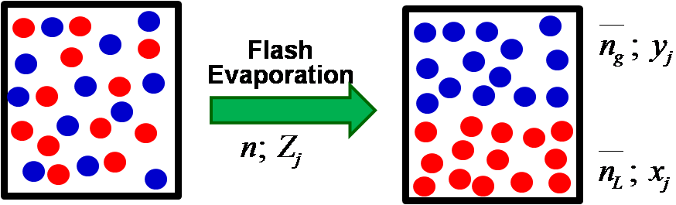

**Figure 2.5: Flash Evaporation Diagram**

To calculate the composition and quantity of both gas and liquid that are in equilibrium in an ideal solution, two major laws that deals with partial pressures of the individual components (say component j ) in the gas are considered.

These are:

1. **Raoult’s Law**

This has the mathematical statement

**Pj = X j PVj**  **→ Eqn. 2-1**

Where;

P j = Partial pressure of component j in the gas phase that is in equilibrium with the liquid in the ideal solution

Xj = Mole fraction of component j in the liquid

PVj = The vapour pressure that component j would exert at the temperature of interest.

Three major conditions on the Raoult’s equation are that

1. The gas must be in equilibrium with the liquid.
2. The solution, gas and liquid are ideal fluids.
3. Being ideal restricts the use of this equation to pressure lower than or equal to 50 psia and moderate temperatures.
4. **Dalton’s law.**

This has the mathematical statement

**Pj = Y j P →Eqn. 2-2**

where;

Pj = Partial pressure of component j in the gas mixture

Yj = Mole fraction of component j in the gas mixture

P = Total pressure exerted by the gas mixture.

The only condition on the Dalton’s equation is that the gas must be an ideal gas whose measured pressure must be below 50 psia and at moderate temperature. The equations 2-1 and 2-2 are combined by Pj removal to give an equation which relates the compositions (Xj and Yj) of the gas and liquid in equilibrium to the total pressure (P) and temperature (T) at which the gas-liquid equilibrium exists.

**Yj P = X j P v j → Eqn. 2-3**

Or

 **→Eqn. 2-3**

Equation 3 can be used to calculate the ratio of the mole fraction of the component j in the gas to its mole faction in the liquid. To determine the values of Yj and Xj another equation is developed through a consideration of a material balance on component j of the mixture.

 **→Eqn. 2-4**

n = total number of moles in the mixture

nL = total number of moles in the liquid

ng = total number of moles in the gas

Zj = mole fraction component j in the total mixture.

From the above,

Zjn = moles of component j in the total mixture

XjnL = moles of component j in the total liquid

Yjng = moles of component j in the gas.

From equation 2-4, since 

 **→Eqn. 2-5**

Similarly,

 **→Eqn. 2-6**

Equations 5 and 6 can further be reduced by considering just one mole of the mixture. We then have;

→ Fraction of one mole of the mixture that is liquid.

→Fraction of one mole of the mixture that is gas.

Substituting in equations 2-5 and 2-6,

 **→ Eqn. 2-7**

 **→ Eqn. 2-8**

Equations 5, 6, 7, and 8 can be used through a trial-and-error solution method to calculate the composition of the gas and liquid phases in equilibrium. Generally, the total composition (Zi, Zj, Zk, Zm Zn, etc.) of the mixture that is in equilibrium will be known through flash calculation, so also are the pressure and temperature at equilibrium.

**For Non-Ideal Mixture**

The Equilibrium equation is as follows



And



Where



The basic procedure for the application of equilibrium calculation in determining quantities of gas and liquid in equilibrium with their respective component mole fractions and the optimum operating pressure at a given temperature is carried out in the following steps.

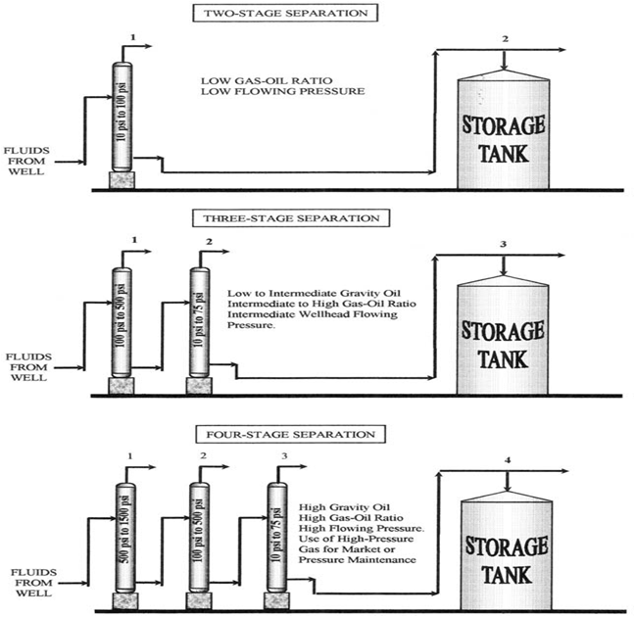

**Fig 2.6: Stage Separation Diagram**

1. Carry out the equilibrium calculation for composition and quantities of separator 1 (SP1) gas and liquid using equation 2-15**.**

 = 1 **→ Eqn. 2-15**

Have trial for ng values until summation equal one. Calculate the quantities of gas and liquid.

1. For separator 2 (SP2) calculations, the liquid from separator 1 (SP1) calculations becomes the feed. So using Xj1 as the feed composition. Then carry out equilibrium calculation for SP2. Continue in this manner until the last stage separator.
2. Calculate the molecular weight and the density of the final stock tank oil.

a. MSTO = ∑XjMj. **→ Eqn. 2-19**

Xj = Mole fraction of component j in the stock tank oil (that is oil from last stage of separation).

Mj = Molecular weight of component j .

MSTO = Total molecular weight of the STO.

b. Calculate molecular weight for C2+ and C3+

c. Determine liquid volume of C3+ at 60 0F and 14.7 psia. Note that C1 and C2 are not considered in the liquid volume due to their minimal presence in liquid at 60 0F and 14.7 psia.

 **→ Eqn. 2-18**

ρOj → Liquid density of component j at 60 0F and 14.7 psia ( from reservoir constant table)

VL → Total liquid volume of C3+ at the same conditions

d. Determine density of C3+ = 

e. Calculate weight fraction of C2.in C2+ = 

f. Calculate weight fraction of methane C1. = Xc1. Mc1

MST

g. Determine stock tank oil density with d and f above.

h. Calculate oil specific gravity γo.=

i. Calculate stock tank oil API

0 API = 141.5 - 131.5

γSTO

**j. Calculate GOR(R)**

RSP = 

If more than just two separation stages, then calculate RSP for SP2

RSP2 =and so on.

k. Calculate stock tank GOR(RST)

RST =

For more number of stages  should be  where n = number of stages.

l. Calculate total GOR (RT)

RT = RSP1 + RSP2 + RSP3 +..........+ RST

m. Calculation of Reservoir Liquid Density and Molecular weight.

1. MOR = ∑XjMj at 60 0F and 14.7 psia

2. Calculate ρOR c 3 +, ρPO, VL as above with C and C fractions and fig. 2-34 at 60 0F and 14.7 psia.

3. Apply compressibility factor and thermal correction to convert to

reservoir pressure and temperature

n. Finally calculate the formation volume factor

res.bbl/STB

**2.5 DEVELOPMENT AND APPLICATION OF SOFTWARE**

The software to be developed is web based softwares that will run on an apache server and the software has the ability to handle equilibrium calculations at varying pressures and temperature with mixture made up of C1 to C10 and ethylene and propylene. The.chapter three of this project contains more detailed information about the software .See figure 2.7 for the software screenshot

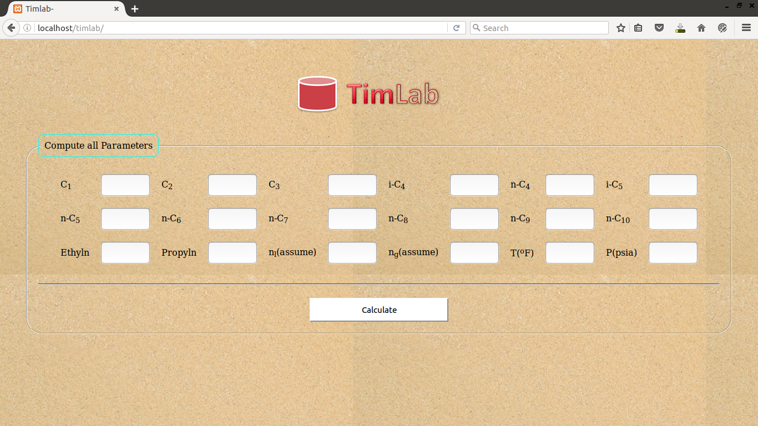

**Figure 2.7 Software interface**

**No references were made in this your literature review.**

**CHAPTER THREE**

**3.1 RESEARCH METHODOLOGY**

The methodology adopted in this project is to develop a software application that can be used to handle phase equilibrium calculations.

**3.2 ABOUT THE SOFTWARE DEVELOPED**

The software developed is a web based application software and is developed using different programming languages such as hypertext preprocessor (P.H.P), Cascading Style Sheet (C.S.S) and Hypertext Markup Language (H.T.M.L).The software has three layers namely;

1. Input Layer
2. Code Behind Layer
3. Output Layer

**Input Layer:** This layer is the part of the application software that handles the user input which is also known as the GUI (**Graphical User Interface**) of the application.

**Code Behind Layer:** This layer is the part of the application software that handles the processing of the user input which is also called the **server side script.**

**Output Layer:** This layer is the part of the application software that handles the display of the output result based on the user input**.**

**3.2.1 TOOLS USED FOR DEVELOPMENT**

1. Notepad++ (Advanced Text Editor)
2. Apache web server
3. Tomcat server
4. Database Server

**3.2.2 REQUIREMENTS TO RUN THIS APPLICATION SOFTWARE**

1. Computer Processor must not be lesser than 1.2 GHZ.
2. Computer Ram must not be less than 1GB for the application to run smoothly.
3. Computer Hard drive space must not be lesser than 1GB.
4. Computer must have an apache server to host the application.

**Provide the System Flow Chart HERE**

**3.2.3 BRIEF INTRODUCTION ABOUT THE PROGRAMMING LANGUAGE**

PHP is a server scripting language, and a powerful tool for making dynamic and interactive Web pages.

PHP is a widely-used, free, and efficient alternative to competitors such as Microsoft's ASP.

**What is PHP?**

1. PHP is an acronym for "PHP: Hypertext Preprocessor"
2. PHP is a widely-used, open source scripting language
3. PHP scripts are executed on the server
4. PHP is free to download and use

**What is a PHP File?**

1. PHP files can contain text, HTML, CSS, JavaScript, and PHP code
2. PHP code are executed on the server, and the result is returned to the browser as plain HTML
3. PHP files have extension ".php"

**What Can PHP Do?**

1. PHP can generate dynamic page content
2. PHP can create, open, read, write, delete, and close files on the server
3. PHP can collect form data
4. PHP can send and receive cookies
5. PHP can add, delete, modify data in your database
6. PHP can be used to control user-access
7. PHP can encrypt data

With PHP you are not limited to output HTML. You can output images, PDF files, and even Flash movies. You can also output any text, such as XHTML and XML.

**Why PHP?**

1. PHP runs on various platforms (Windows, Linux, Unix, Mac OS X, etc.)
2. PHP is compatible with almost all servers used today (Apache, IIS, etc.)
3. PHP supports a wide range of databases
4. PHP is free. Download it from the official PHP resource: [www.php.net](http://www.php.net/)
5. PHP is easy to learn and runs efficiently on the server side

**3.3 THE EQUATIONS USED TO DEVELOP THE SOFTWARE**

For Non-Ideal Mixture, The Equilibrium equation is as follows



And



Where



**Vapor-Liquid Equilibrium Calculations Using K Values**

The vapor-liquid equilibrium constant or distribution coefficient for component A is defined as



where Yj = mole fraction of j in the vapor phase and Xj = mole fraction of A in the liquid phase

For light hydrocarbon systems (methane to decane), the K values have been determined semi-emperically and can be evaluated from the equations given in Table 3.1. In general, K is a function of temperature, pressure, and composition.

**Table 3.1. Equilibrium K values for light hydrocarbon systems**

(1) ln K = -A/T2 + B - C ln(P) + D/P2

(2) ln K = -A/T2 + B - C ln(P) + D/P

(3) ln K = -A/T + B - C ln(P) , where P is in psia, T is in oR

Compounds A B C D Form

=============================================================

Methane 292860 8.2445 .8951 59.8465 (1)

Ethylene 600076.9 7.90595 .84677 42.94594 (1)

Ethane 687248.2 7.90694 .866 49.02654 (1)

Propylene 923484.7 7.71725 .87871 47.67624 (1)

Propane 970688.6 7.15059 .76984 6.90224 (2)

i-Butane 1166846 7.72668 .92213 0 (1)

n-Butane 1280557 7.94986 .96455 0 (1)

i-Pentane 1481583 7.58071 .93159 0 (1)

n-Pentane 1524891 7.33129 .89143 0 (1)

n-Hexane 1778901 6.96783 .84634 0 (1)

n-Heptane 2013803 6.52914 .79543 0 (1)

n-Octane 7646.816 12.48457 .73152 (3)

n-Nonane 2551040 5.69313 .67818 0 (1)

n-Decane 9760.457 13.80354 .7147 (3)

**3.4 HOW THE SOFWARE APPLICATION WORKS**

It works in a way whereby the user enter an input at the GUI (Graphical user interface) and this input are the composition of each compound in a mixture ,Temperature and pressure.

And after the successful entry of the data , the user then click the **calculate button** and it then displays the ouput results.

**3.5.. SOFTWARE VALIDATION**

**Carry out a validation process for your developed software by using it on already calculated works in the industry(as case study).**

**Discuss this in chapter 4**

**CHAPTER FOUR**

**4.1 ANALYSIS OF RESULT**

This chapter entails the analysis of the result from the methodology in chapter three.

**4.2 SOFTWARE GUI SCREENSHOT**

The figure below shows the graphical user interface screenshot of the software application,

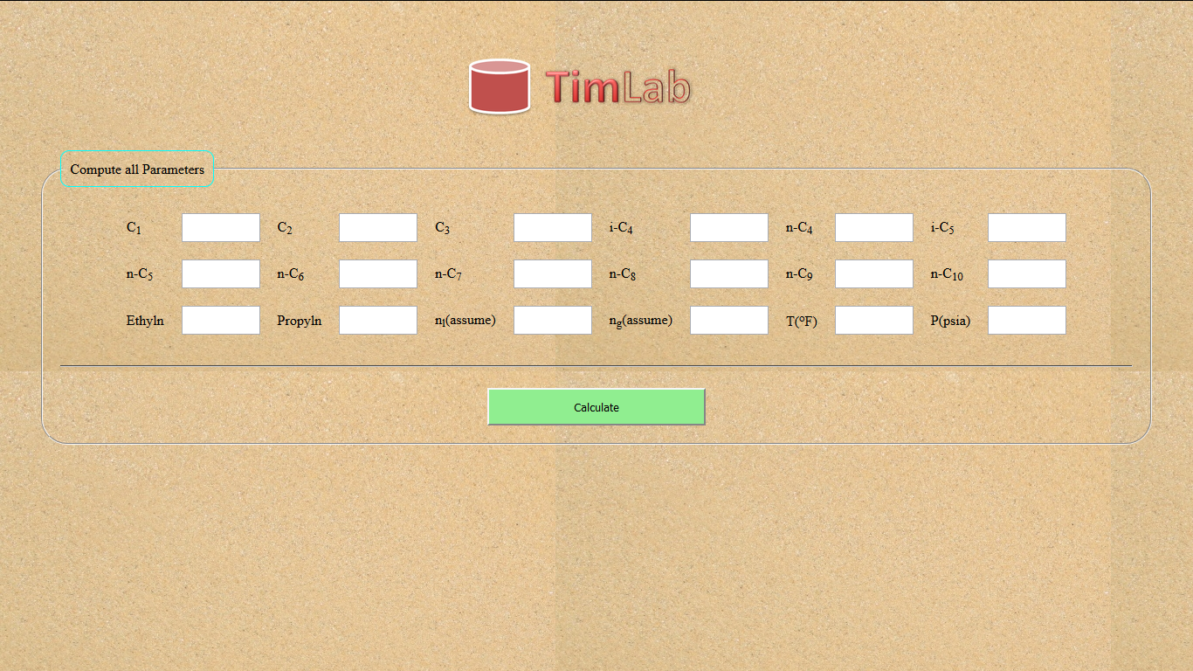

Figure 4.1 The Graphical user interface of the software application

**Discuss the Validation for Your Work here**

**4.2 SOFTWARE RESULT OUTPUT SCREENSHOT**

This screenshot below present the output result generated by the software

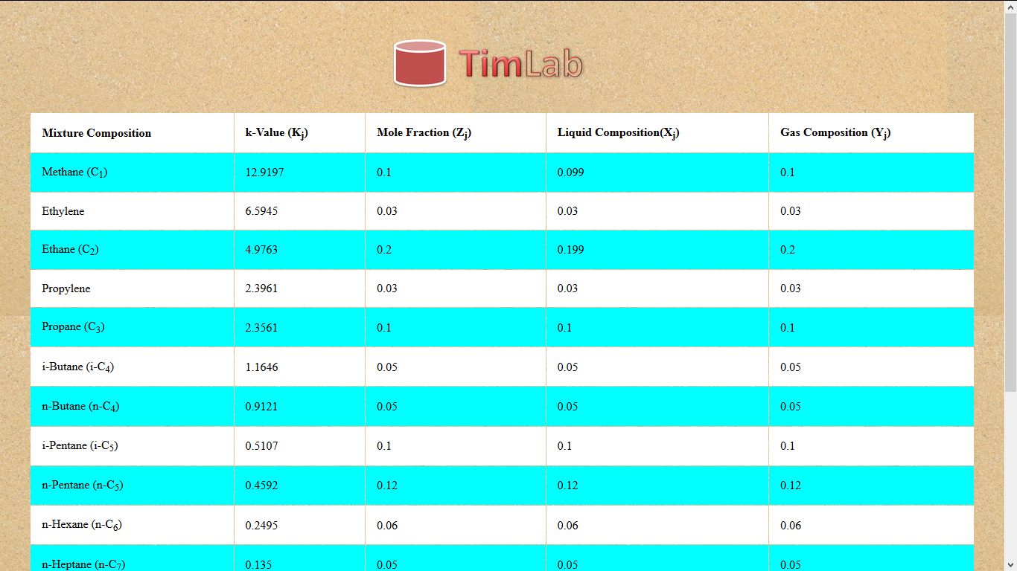

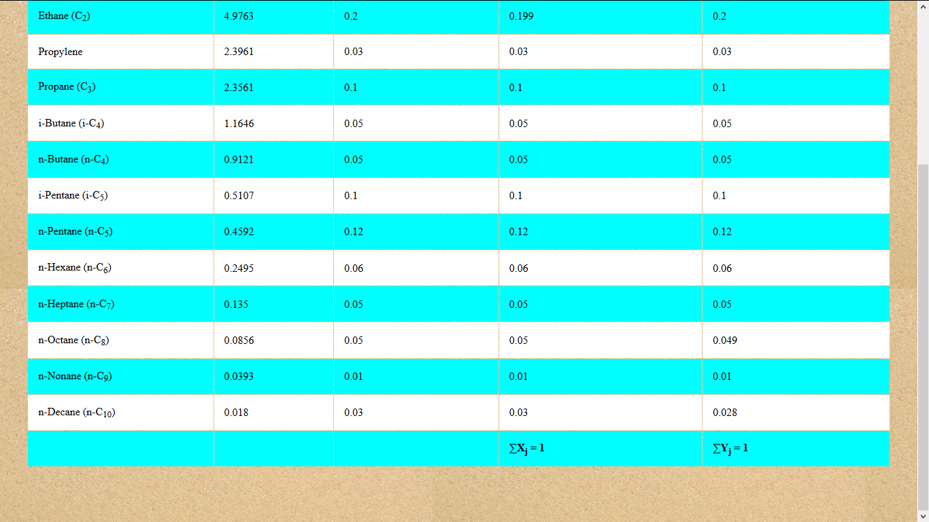

Figure 4.2 The result output layer of the application software

Where is the fluid composition that gave you these results?

**CHAPTER FIVE**

**CONCLUSION**

At the end of this project work , It can be concluded that this project work has made me more grounded in the development of engineering softwares and at the end of this project work the end result was achieved.

**RECOMMENDATION**

It should be recommended that all petroleum engineering students should be introduced and be more grounded in engineering software development because it was not easy to develop a software individually without getting acquainted with various programming languages such as Java , HTML ,CSS , VB.NET etc. So the petroleum engineering department should include programming in the syllabus and it must be made compulsory for all students to take it as course.

**The Objectives of your work I remind again**

* 1. To design a New Software(XYZ) to handle phase equilibrium calculations
  2. Apply XYZ to separate the Light Group (C1 and C2) from oil.
  3. Apply XYZ to maximize the recovery of heavy components of the intermediate group in crude oil

The Scope is limited to:

Determine hydrocarbon fluid composition at the separator, stock tank Gas-Liquid equilibrium, stock tank liquid density, Gas-Oil ratio, and reservoir liquid density and Formation volume factor for a given reservoir fluid composition.

***NOW!***

1. Your final result table shows only the components mole fractions of the gas and liquid in equilibrium.
2. Nos 2 1nd 3 of your objectives were not taken care neither are the items in your scope.
3. Make all the corrections and attend to the observation and return to me immediately